8051 based digital clock using LCD display (Code+Proteus simulation)
This post provides the implementation of a digital clock display ( using c language ) for 8051 micro-controller ( e-g for AT89C51 or AT89C52 etc ). The LCD display is continuously updated after every second with the new value of current time in HH:MM:SS format.
The code and Proteus simulation is given in the 'Downloads' section at the bottom of this page. It is assumed that you know how to interface an LCD with 8051 micro-controller in 4bit mode. If you don't, then please read this post first.
The following figure shows the circuit of digital clock using 8051 in Proteus.
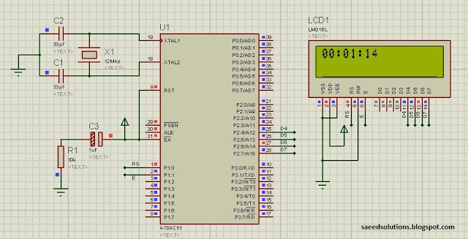
Figure 1. Digital clock display using 8051 micro-controller
The above figure was taken at time, 1 minute and 14 seconds after the start of simulation in Proteus. The LCD update rate is 1 Hz i-e LCD is updated with new value of current time after every second.
The code for the main function is shown below.
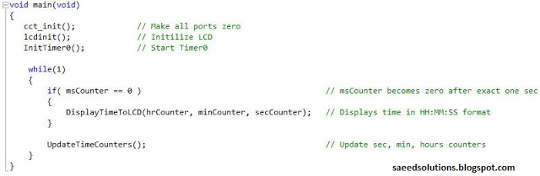
Figure 2. Main code for digital clock using 8051
Timer0 is used in this code to generate the base for the clock. To read about how to configure the timer0 for 8051 micro-controller, please read this post.
Timer0 increments the msCounter variable, after exactly 1ms. And when msCounter reaches 1000, then its value is reset to 0 again. At this instant, 1 second time is elapsed and DisplayTimeToLCD() function is called, which displays the new updated time on the LCD.
There are some global variables which store current time. These variables are used through out the code. For example, msCounter stores the current milli-second count. And secCounter stores the current value of seconds, minCounter stores the current value of minutes, hrCounter stores the current value of hours etc.
The code for timer0 interrupt service routine function and also for the UpdateTimeCounters() function is displayed below.
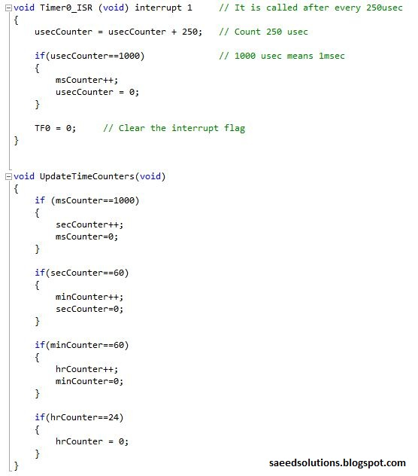
Figure 3. Timer0 ISR and UpdateTimeCounter functions
In the timer0 ISR, usecCounter variable (which stores the current value of micro-seconds) is incremented after every 250usec (As timer0 is configured to give an interrupt after every 250usec). When usecCounter reaches 1000 value (i-e 1000usec = 1msec), then msCounter variable is incremented.
In the UpdateTimeCounters() function, whenever msCounter reaches 1000 (i-e 1000msec = 1sec), then it increments the secCounter. Similarly, when secCounter reaches a value of 60, then minCounter is incremented and so on. This "update time counter" function ensures each variable has correct value to display time.
The actual function which displays time on the LCD is shown below.
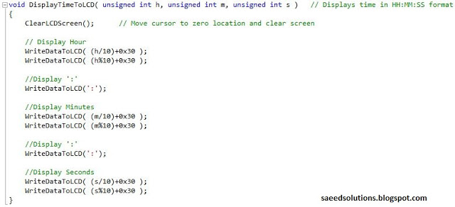
Figure 4. DisplayTimeToLCD function code
DisplayTimeToLCD() function displays the current time value on the LCD in HH:MM:SS format. Firstly, LCD screen is cleared, then Hours value is displayed on the screen. Then ':' symbol is displayed on the LCD. After which Minutes are displayed, then ':', and in the end seconds are displayed. All of this happens so fast, that we instantly see new updated value on the LCD.

